**PROBLEM STATEMENT**

In this project, we will take up the challenge of writing JavaScript code that will allow us to add social share buttons to static sites. While we can do this by incorporating HTML elements or images in the site’s template, using JavaScript allows us to add the share buttons dynamically.

**RESULTS**

**Home Page: -**

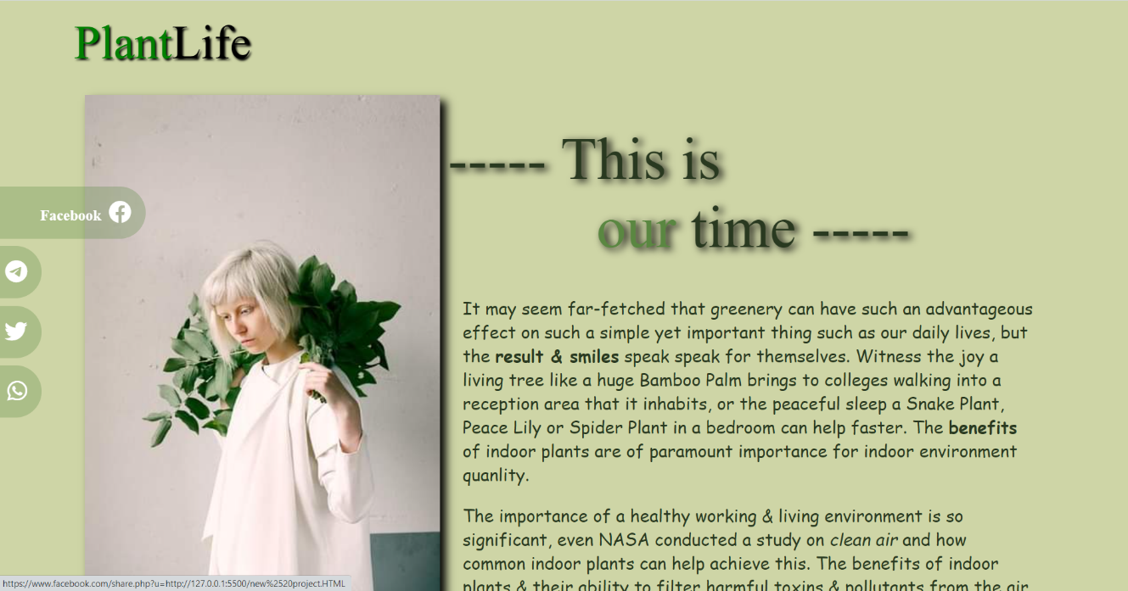

**Code Snippet: -**

